**TrafficTelligence: Advanced Traffic Volume Estimation with Machine Learning**

**1. INTRODUCTION**

**1.1 Project Overview**

TrafficTelligence is an intelligent traffic forecasting system powered by machine learning. It predicts real-time traffic volume based on factors like weather, day/time, and historical trends. This project empowers city planners and commuters with data-driven insights to reduce congestion and improve road usage.

**1.2 Purpose**

The purpose of this project is to develop a system that leverages ML to estimate traffic volume with precision, helping city authorities plan efficiently and allowing travelers to make smarter commuting choices.

**2. IDEATION PHASE**

**2.1 Problem Statement**

Increasing urban traffic leads to congestion, time loss, and pollution. A lack of predictive traffic systems limits proactive planning.

**2.2 Empathy Map Canvas**

* **Think & Feel:** Wants accurate forecasts
* **Hear:** Complaints about traffic
* **See:** Congestion everywhere
* **Say & Do:** Plans trips inefficiently
* **Pain:** Wasted time in traffic
* **Gain:** Real-time data to improve commute

**2.3 Brainstorming**

Ideas considered:

* Basic traffic dashboard
* Real-time Google Maps alternative
* Forecast model using weather and time  
  Chosen idea: Prediction system with data visualization and downloadable logs

**3. REQUIREMENT ANALYSIS**

**3.1 Customer Journey Map**

User enters inputs → Backend predicts volume → Output displayed → Log stored → User downloads CSV

**3.2 Solution Requirement**

**Functional Requirements:** Traffic prediction, UI interface, log storage  
**Non-Functional Requirements:** Usability, performance, scalability

**3.3 Data Flow Diagram**

See attached diagram (Image included in full submission).

**3.4 Technology Stack**

* **Frontend:** HTML, CSS, JS
* **Backend:** Python (Flask)
* **ML:** Scikit-learn
* **Database:** CSV-based log storage

**4. PROJECT DESIGN**

**4.1 Problem Solution Fit**

Real-time traffic prediction is essential to solve congestion and route inefficiency problems.

**4.2 Proposed Solution**

A lightweight ML-based web app that predicts traffic volume and displays trends using UI and logs.

**4.3 Solution Architecture**

Flow: UI Input → Backend Flask → ML Model → Prediction + Logging → UI Display + File Log  
(Architecture image included)

**5. PROJECT PLANNING & SCHEDULING**

**5.1 Project Planning**

Sprint 1: Data Collection, Preprocessing, Model Training  
Sprint 2: Evaluation, UI design, Visualization, Logs  
Sprint 3: Admin tools, Model upload, Final testing

**6. FUNCTIONAL AND PERFORMANCE TESTING**

**6.1 Performance Testing**

ML model evaluated using metrics: MAE, RMSE, R2  
Prediction latency under 500ms per request.

**7. RESULTS**

**7.1 Output Screenshots**

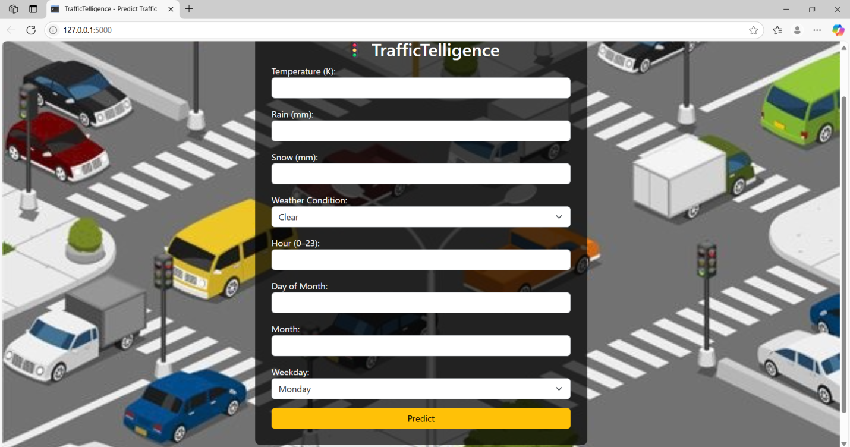

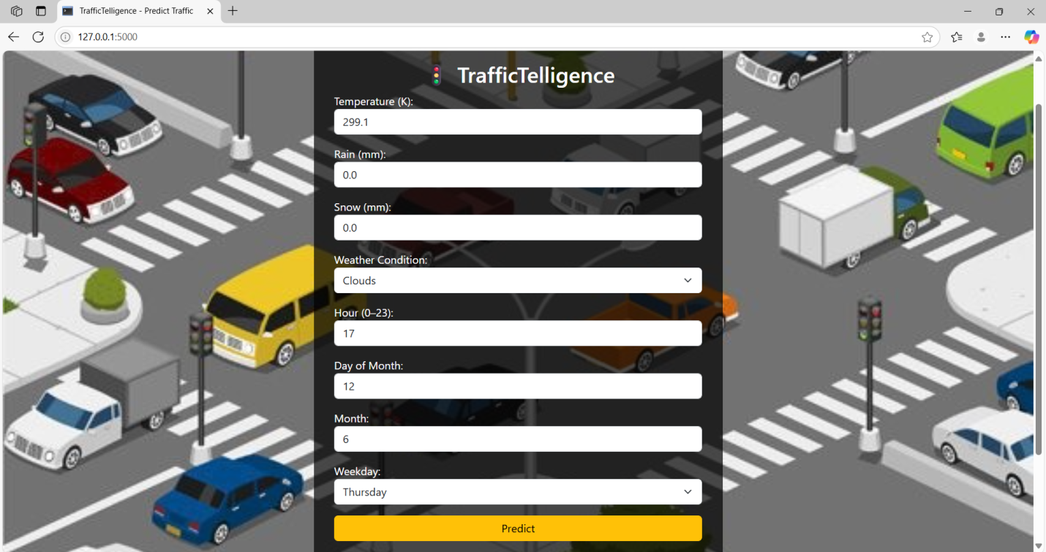

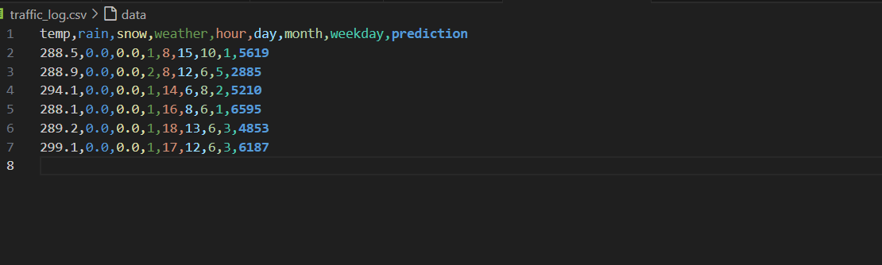

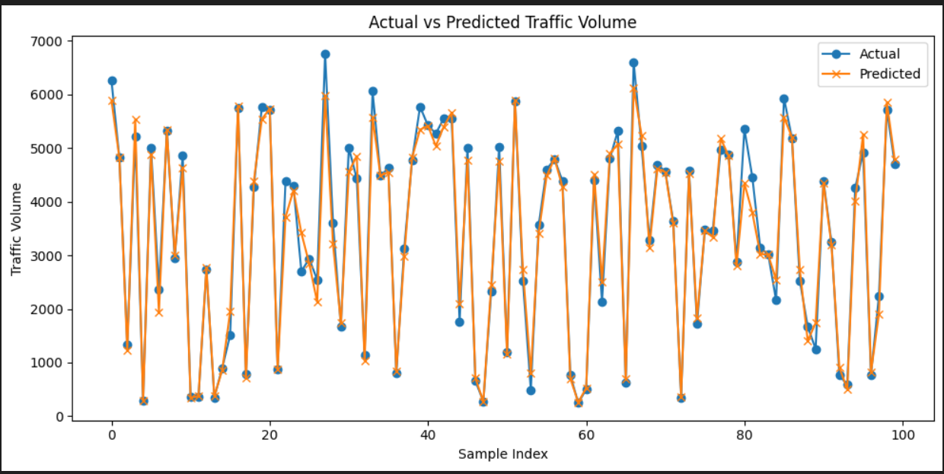

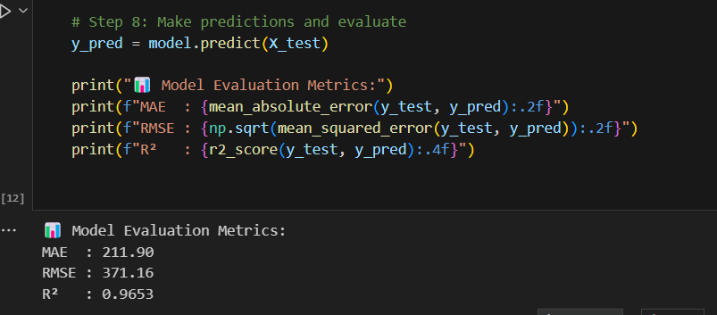

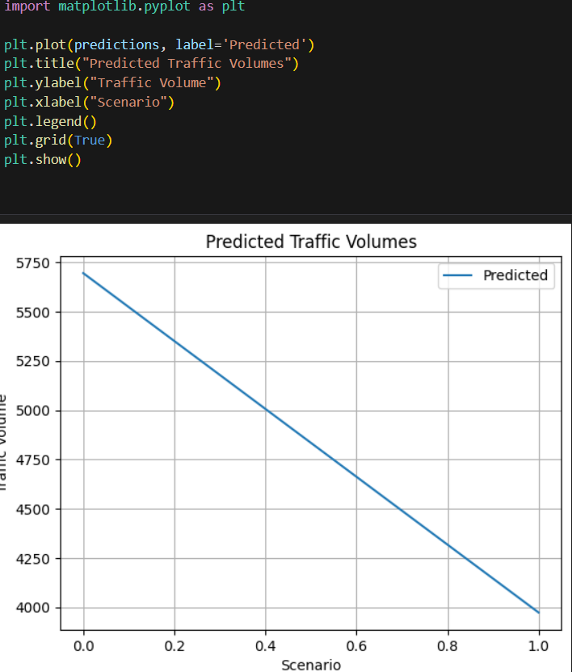

**8. ADVANTAGES & DISADVANTAGES**

**Advantages:**

* Real-time traffic estimation
* Easy to use interface
* Lightweight web-based solution

**Disadvantages:**

* Predictions rely on static data
* Lacks live sensor/GPS inputs

**9. CONCLUSION**

TrafficTelligence proves that ML can enhance traffic prediction for smart cities. It can reduce congestion and help better decision-making for commuters and administrators.

**10. FUTURE SCOPE**

* Integrate with real-time traffic APIs
* Add GPS and sensor-based input
* Deploy to mobile app platform

**11. APPENDIX**

* **Source Code:** Included in GitHub repo
* **Dataset Link:** https://drive.google.com/file/d/1iV5PfYAmI6YP0_0S4KYy1ZahHOqMgDbM/view
* **GitHub:** <https://github.com/your-username/traffic-telligence>
* **Project Demo:** https://youtu.be/IuEKecKAwMc